***PROJECT***

***REPORT***

***DEMONSTRATION***

***1.INTRODUCTION***

***OVERVIEW***

***Designing visually applying certificate for a depabe compittion using canva***

*The creating Informatic in Infragraphic for college Prresesentation using canva the project focus on developing visually enhancing and informatics infragraphics to enhance the quality effectiveness college of presentation*

***PURPOSE***

*The Project assigned that the skills of Using technology to create the Designing infragraphic using Canva with help of Canva application*

***2.PROBLEM DEFINITIONS AND DESIGNIN THINKING***

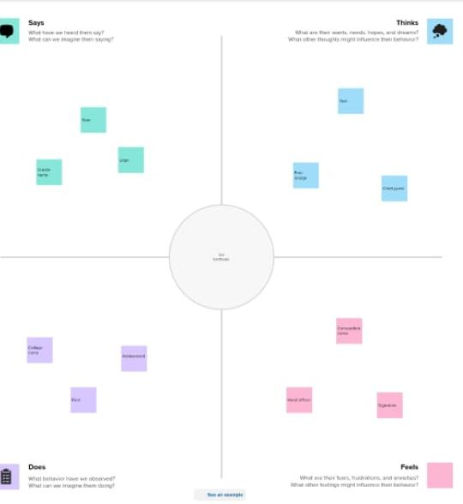***EMPATHY MAP***

***BRAINSTORMING MAP***

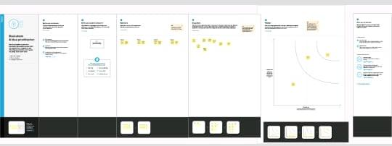

***3.RESULTS***

***PROJECT NAME DESIGN INFRAGRAPHIC USING CANVA***

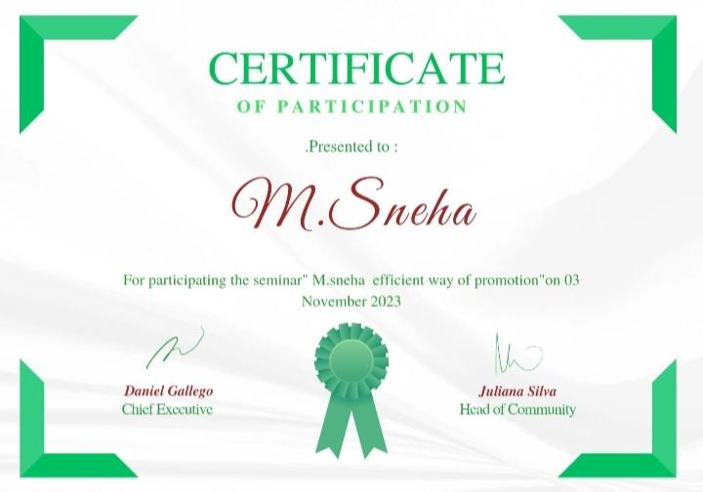

***4.Advantages And Disadvantages***

***Advantages***

|  |  |
| --- | --- |
| *Advantages* | *Disadvantages* |
| *It used effectively communication* | *Same logo,image, design costly* |
| *It is ecnomical* | *Email ID is mandatory* |
| *It is used friendly* |  |
| *It canva there are lot of activities for presentation* |  |

***5.APPLICATION***

*THE CANVA Application is very useful to create my project easily .It helps with new templates it will be useful in my future*

***6.CONCLUSION***

*NAAN MUDHALVAN SCHEME I am a student in Government Arts and Science College vedasandur, Assigned my project to be done with help of Canva Application.I have learned that usage of canva App well and it is very user friendly.*

***Presented by***

***M.SNEHA***